Press release ifm-pm 827/0725
Area: Position sensors

Powerful object detection in confined spaces
Nuremberg, 25 November 2025 – Fibre-optic sensors are the ideal solution when installation space is limited. For such applications, ifm is now launching the new OCF series fibre-optic sensors. These can be set up intuitively, have numerous smart functions thanks to IO-Link and offer six powerful operating modes that the fibre-optic amplifier automatically selects when required.
Fibre-optic sensors operate on the same principle as conventional photoelectric sensors. However, the lens and the evaluation electronics are spatially separated from each other in this case, which offers an important advantage for many applications: The optical fibres can be positioned precisely in very confined spaces and detect even very small parts there. The remote fibre-optic sensor is then located in a suitable place, for example, mounted on the machine or even in a control cabinet.
The new OCF series fibre-optic sensors make such applications particularly easy. The narrow housings are suitable for mounting on DIN rails. There, they can be simply clipped on. The optical fibres can also be connected without tools thanks to fibre-locking. Since the OCF complies with the high IP65 protection rating, it can also be mounted in the field, for example, directly on the machine. During development, ifm placed great emphasis on usability to ensure that subsequent set-up would be simple and intuitive. The fibre-optic sensor has three buttons for operation. The plain text display of the integrated OLED display facilitates the 2-point teach-in. With the find-me function, localisation is simplified thanks to the flashing fibre. The OCF has six different operating modes. The output signal can be sent to a higher-level control system via IO-Link as well as via a fast digital output. The IO-Link interface is also used for diagnostics of the fibre-optic sensor. For example, the degree of soiling of the fibre can be monitored. This clean-me function enables predictive maintenance in the application. Together with the new fibre-optic sensors, ifm also offers a comprehensive range of matching fibre optics in a wide variety of designs so that the right configuration can be selected for every application. Typical applications include confined spaces as well as use in high temperatures or chemically aggressive environments. Further information on the OCF can be found on the website.
ifm at SPS: hall 7A, stand 302

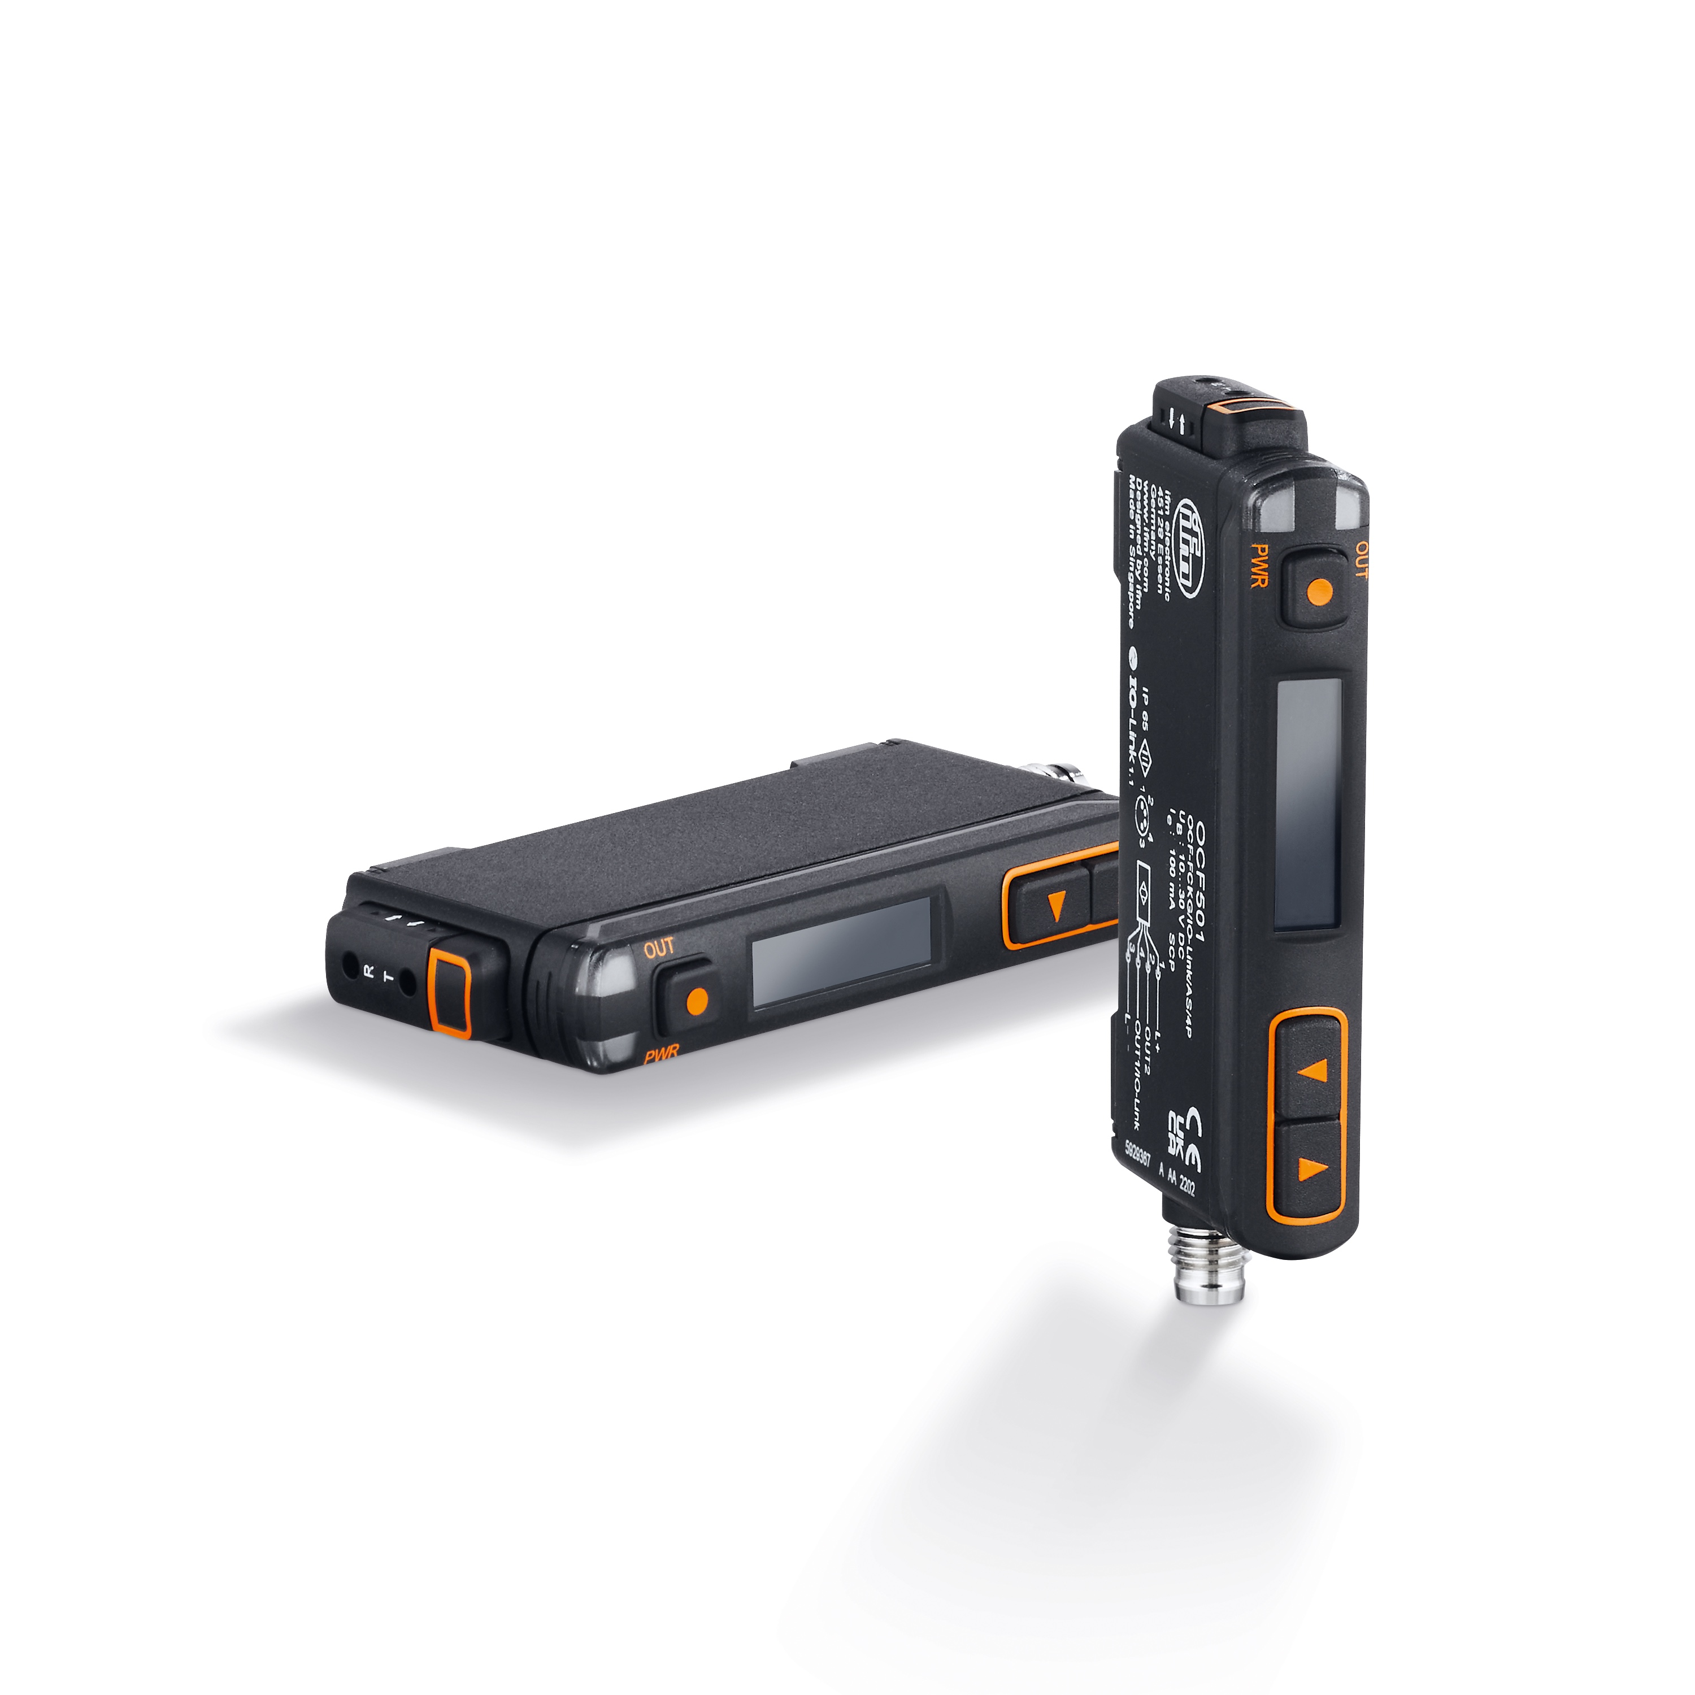 | ifm-pm 875 print.jpg  The OCF fibre-optic sensor sets a new standard for detecting small parts in confined spaces.

About the ifm group of companies

From a passion, to an idea, to success. Since its foundation in 1969, ifm has developed, produced and sold sensors, controllers, software and systems for industrial automation and for SAP-based solutions for supply chain management and shop floor integration worldwide. As one of the pioneers of Industry 4.0, ifm develops and implements consistent solutions to digitalise the entire value chain “from sensor to ERP”. Today, the second-generation family-run ifm group has more than 8,760 employees and is one of the worldwide market leaders. The group combines the internationality and innovative strength of a growing group of companies with the flexibility and close customer contact of a medium-sized company.
Printing free of charge – reference copy requested.

Editorial enquiries  Agentur Dr. Lantzsch  Jörg Lantzsch  Müllerstr. 5  65183 Wiesbaden  www.drlantzsch.de  Tel.: +49 611 205 93 71  Email: info@drlantzsch.de | Contact  ifm electronic gmbh  Simone Felderhoff  Friedrichstr. 1  45128 Essen  www.ifm.com  Tel.: +49 201 24 22 0  Fax: +49 201 24 22 1200  Email: presse@ifm.com

